WWCLASS → OLRF
(prepared by : Subhas.Khasnabish@hp.com)

- Description :
This functional module is a User Interface which facilitates Business Users to submit Classification request online for HP Parts as well as for Non-HP NPNs (No Product Numbers). This newly developed module includes all functional capabilities of the existing one and also covers all key BRD specifications. It is also intended to optimize associated IT support/maintenance processes in alignment with HPIT Standards.

- Key Functionalities :
- OLRF for HP Parts :
  - Allows to submit Classification request for newly created Part Numbers from Master Data Feed.
  - Checks whether the Classification request has already been submitted earlier for the Part Number and then allows users to submit Classification request for similar Additional Parts by transferring the details from the Reference Part Number.
  - Transfers old Question Set / Classification Description of the Base Part Number submitted earlier with old OLRF Tool to the Similar Additional Parts.
  - Displays Classification Request Form for entering necessary details
  - Allows users to upload Additional Similar Parts (Maximum 25 using a single file) from a Tab Delimited Text File.
  - Facilitates users to download Question Set into Excel Spreadsheet.
  - Performs Input Validation for Mandatory Fields and Email Addresses
  - Validates all HP Email Ids against HP Enterprise Directory
  - Sends Email to designated people.
  - Configuration Options Vs. Localization Options : Under current formatting process for Part Numbers, the Configuration Options (usually entered with “#” (e.g. A123#001) and the Localization Options both share the same Character Position (i.e. 13th Character Position) of the Part Number. In order to avoid the conflict, if the Part Number contains Configuration Option, then it disables the selection of Localization Options for HP Parts. For Regular Part Numbers (not containing Configuration Options), the tool generates new Part Numbers based on selected Localization Options.
  - Updates Database
    - Adds New Part Information to Part Table for the Base Part Number.
    - If the Base Part Number and/or Additional similar Part Numbers do not contain Configuration Options (e.g. A123#001), the tool generates New Part Numbers based on selected Localization Options by appending the Localization Option codes to the Part Numbers starting from 13th Character position onwards.
    - Adds Entries to Custom and Export Workbuffers based on Country selection.
    - Adds Entries pertaining to Questions and Responses for selected Category to the Classification Description Table in a long concatenated format.
    - Adds Entries to Audit Trail Tables against the New Part Numbers.

- OLRF for NPNs :
  - Displays Classification Request Form for entering necessary details
  - Performs Input Validation for Mandatory Fields and Email Addresses
  - Validates all HP Email Ids against HP Enterprise Directory
  - Sends Email to designated people and to Class support Team Mailbox.

Note: Use of NPN Parts is governed by HP Policy HP20-14, prescribing there use to support of NON-COMMERCIAL shipments ONLY. All revenue based shipments (Parts/Products) must have a valid HP Part/Product number, the characteristics of which are defined under HP Policy HP020-12.

- Home Page :
Production : http://wwclassprod.austin.hp.com/clshome.htm
ITG/Test : http://wwclasstest2.atlanta.hp.com/clshome.htm

- Menu Path :
WWCLASS Home Page → Online Request Form ^{new}
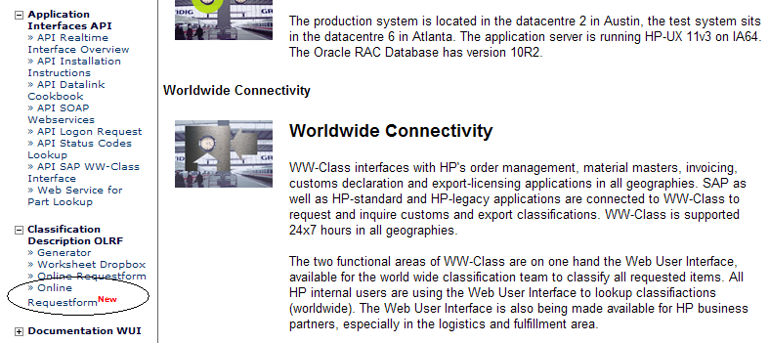

- Operational Instructions :

- Initial Display :
  - In the initial screen for OLRF, user is required to select whether the Classification Request if for HP Parts or Non-HP NPNs.
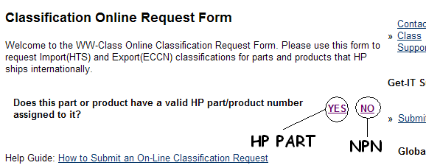
  - Based on the response for the user the tool switches either to Classification Form for HP Parts or for NPNs.

- OLRF → Classification Request Form for HP Parts :

  - At the beginning, the Tool asks for the Part Number to enter.
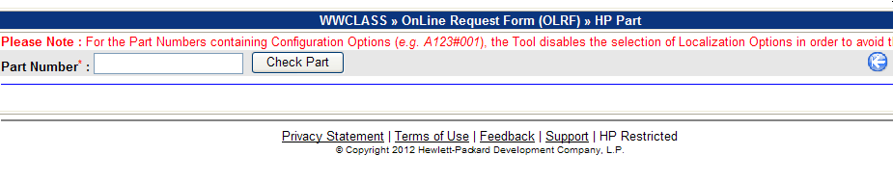
  - Enter Part Number and then Click “Check Part” Button to check whether the Part Number has already been submitted earlier for Classification. If Part Number is not entered the tool displays the Error Message as shown below.
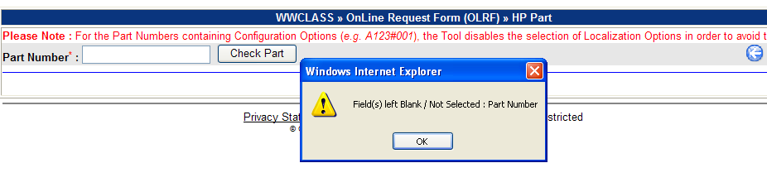
    - If the Part Number is found but no Question Set / Classification Description is available, then the Tool asks for the Confirmation whether the user wants to proceed with Classification Request for the Part Number.
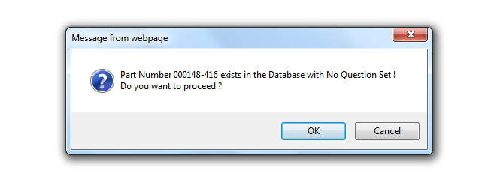
    - When “OK” Button is clicked, the Tool asks to enter the Category for the Question Set / Classification Description as shown below :
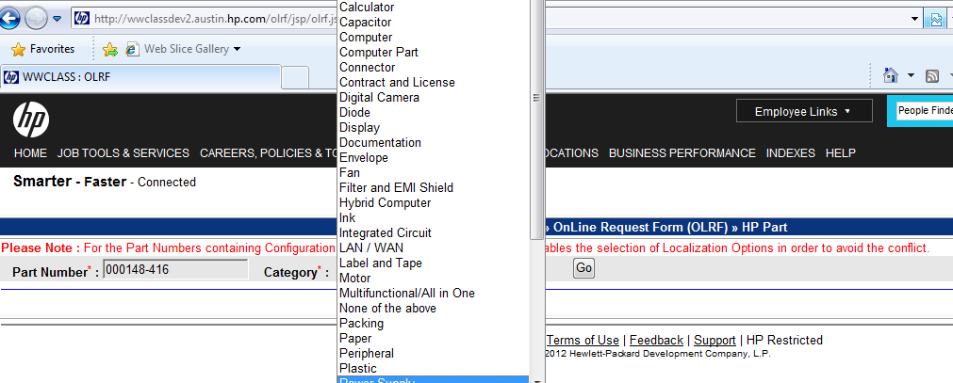
    - A valid Category must be selected from the Drop-down box otherwise the Tool will show the Error Message :
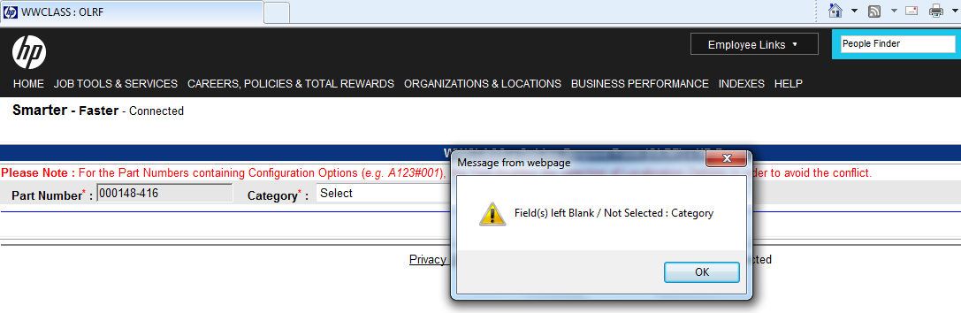
    - On receipt of a valid Category, The Tool pre-populates the Part Description and Commercial Description (not editable) Fields and allows users to proceed with normal Classification Request Process explained in later sections of this document.
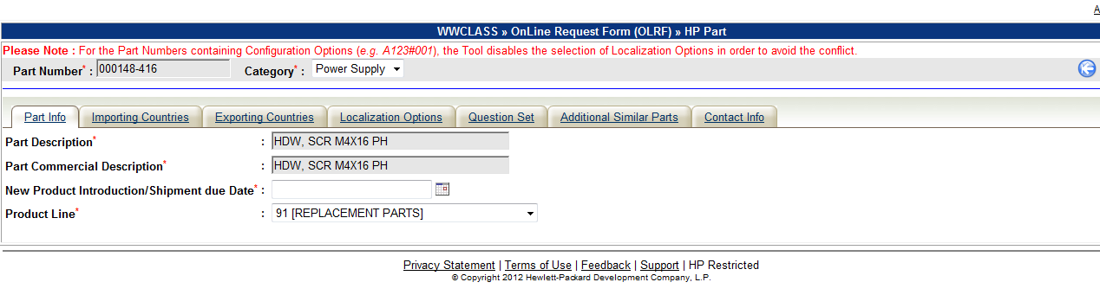
    - If the Part Number is found with the Question Set / Classification Description, then the Tool asks for the Confirmation whether the user wants to proceed with Classification Request for Similar Parts.
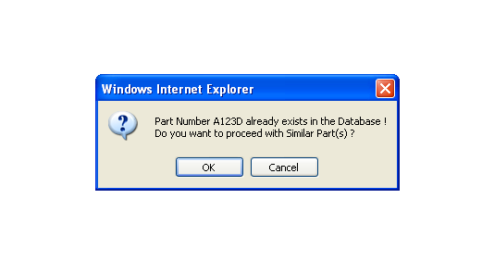
    - Click “OK” Button to proceed with Classification Request for Similar Parts. In this case, the tool pre-populates the attribute values of the Part Number entered onto the Classification request.
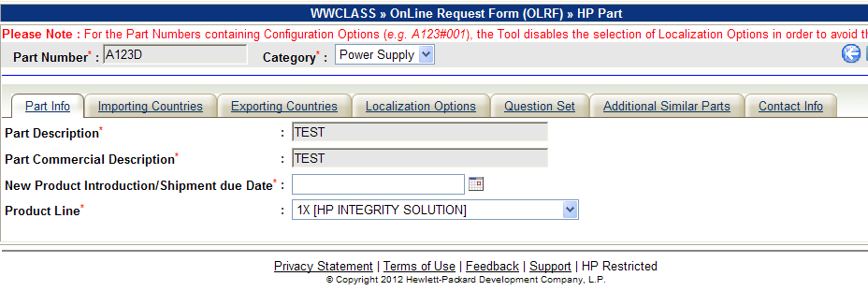

    - The Following Fields are pre-populated :
      - Part Description (Read Only)
      - Part Commercial Description (Read Only)
      - Product Line (Editable)
      - Importing Countries (Editable)
      - Exporting Countries (Editable)
      - Question Set (Not editable)
    - Click “Cancel” Button for not to proceed with Classification Request for Similar Parts. In this case, the Tool goes back to the Initial screen.
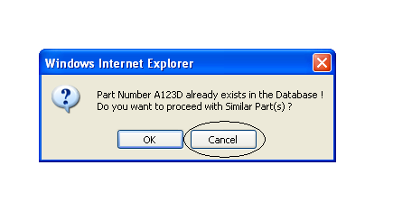.
    - If the Part Number is new and not found in the Database, then the tool asks to select the “Category” from the Drop-Down List.
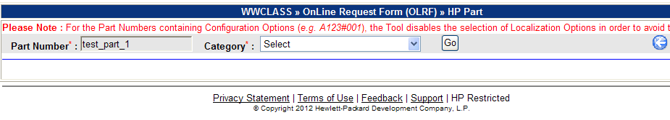.
    - Select “Category” from the Drop-down list.
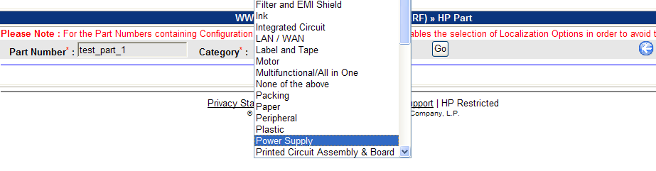
    - If the “Category” is not selected, the tool displays the Error Message as shown below :
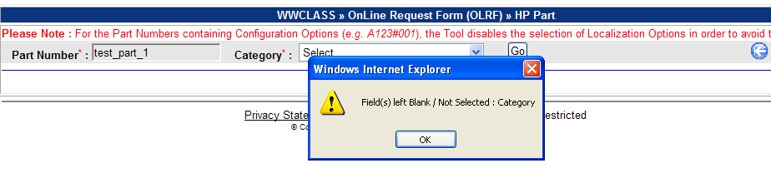

    - For New Part Number, Click “Go” Button to submit the selected Part Number and Category. On receipt of valid new Part Number (should not exist in the Database) and Category the Tool displays the Classification request form in “Tab” Format.

  - The following Control Buttons/icons are displayed :
    - → Start Over (When clicked, it refreshes the screen, wipes out data from previous operations.)
    - → Information/Instructions (When Clicked, displays popup window to show Information/Instructions)
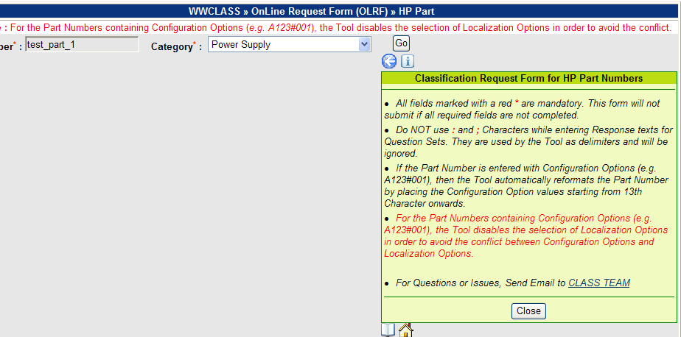
    - → User Guide for Operational Instructions
    - → Home (When Clicked, displays Home Page and Part Lookup Links.)
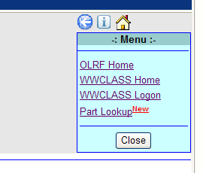

  - Next Screen : Detail Classification Request form :
    - On receipt of a Valid Part Number and Category, the next screen displays the detail Classification Format in “Tab” format. Each “Tab” show relevant input section to be filled in. The Input fields marked with red Asterisks * denote mandatory fields to be filled in :
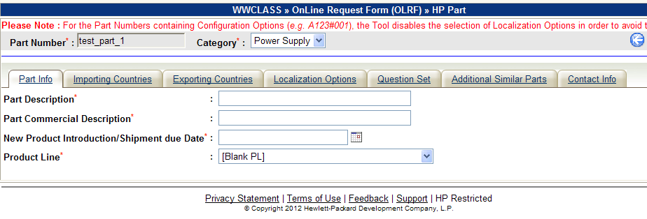
    - Tab : Part Info :
      - Following Fields are mandatory to be filled in :
        - Part Description (Maximum Length : 40 Characters)
        - Part Commercial Description (Maximum Length : 40 Characters)
        - New Product Introduction/Shipment due Date : (Click to select the Date. If the Date is selected within 3 days from the Current/Today’s Date, then the user is required to fill in information about Business Justification and Email Address of Authorizing Manager as shown below)
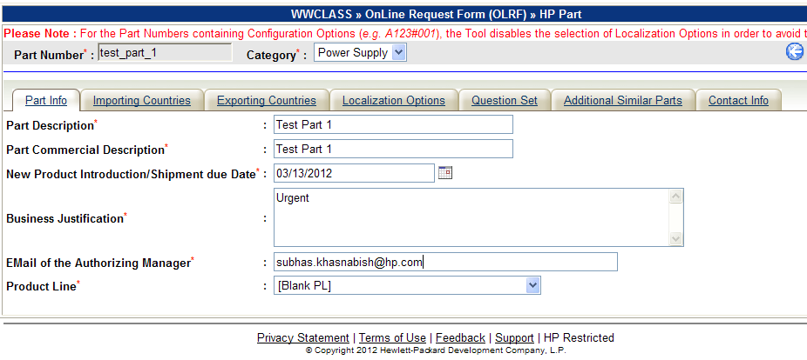
          - Business Justification (Maximum Length : 500 Characters)
          - Email of the Authorizing Manager (Should be a valid HP Email Address)
        - Product Line (Select from Drop-down List).

    - Tab : Importing Countries (Optional)
      - Importing Countries “Tab” allows user to select Countries for Custom Classification based on the Regions.
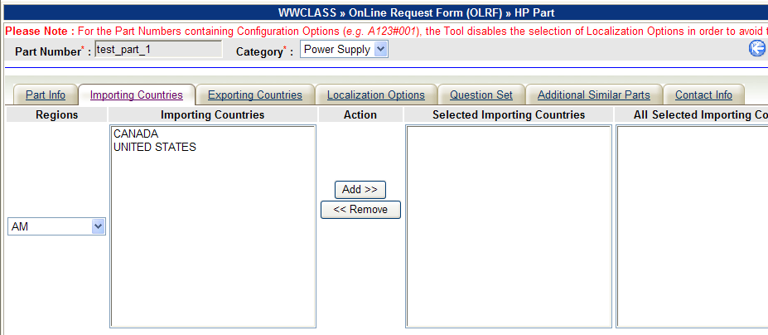
      - Following operations can be performed.
        - Selection of Region (From the left most Drop-down list Specific Region can be selected. When a Region is selected, the corresponding Countries belonging to that Region will appear inside the block of “Importing Countries” as shown below).
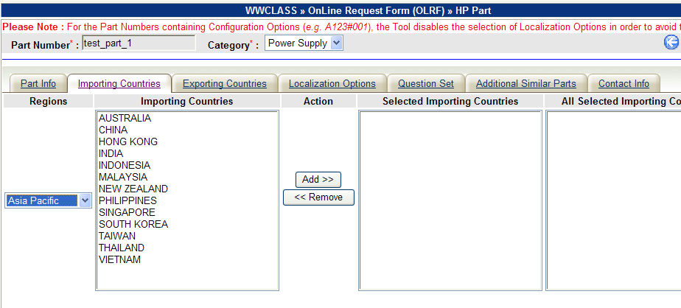
        - Selection of Multiple Importing Countries (Select/Highlight Country name to be selected. In order to select multiple Countries (not continuous), hold <ctrl> button on the keyboard and then click on next country as shown below. In order to select continuous group of countries, select the first Country and then hold <shift> button on the keyboard and click the last country to be selected as shown below)
          - Selection of multiple countries (not continuous) using <ctrl> and Mouse Click
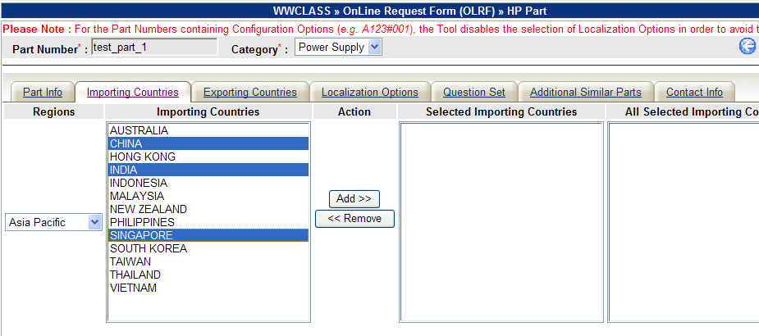
          - Selection of multiple countries (continuous) using <shift> and Mouse Click.
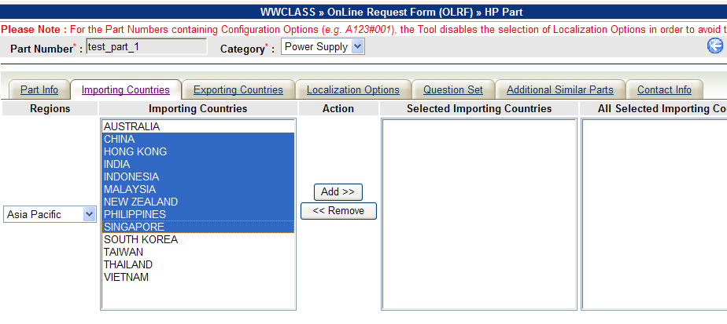
        - After highlighting the Countries (as shown above), click “Add” Button to add them into the “Selected Importing Countries” Block.
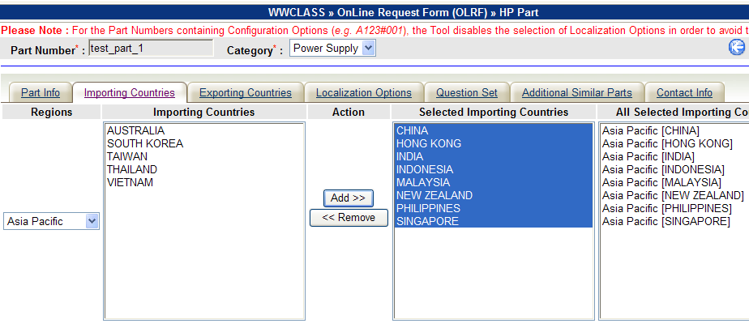
        - The Last Block titled “All Selected Importing Countries” shows the cumulative selection of Countries for all selected Regions.
        - The same process can be repeated to select Countries from other Regions. The last block will show the cumulating selection of Countries for all selected Regions.
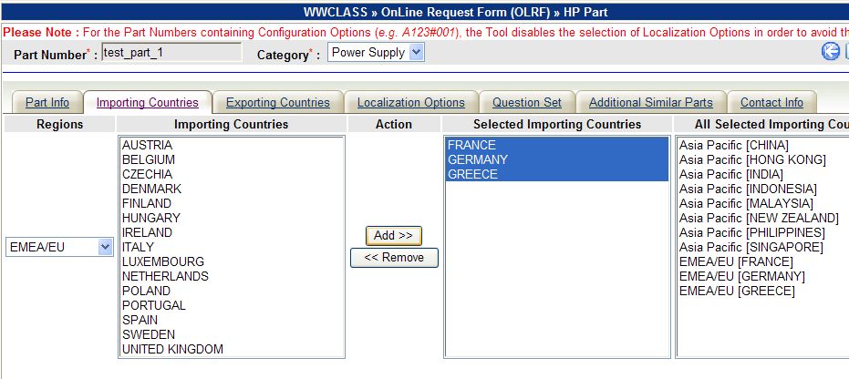
        - Deselecting Countries or Removing Countries from “Selected Importing Countries” Block : (Select/Highlight multiple countries from “Selected Importing Countries” Block using <ctrl>-Mouse Click or <shift>-Mouse Click techniques as described above and then click “Remove” button. The selected countries will be removed from “Selected Importing Countries” and “All Selected Importing Countries” blocks and will be appended to the “Importing Countries” block)
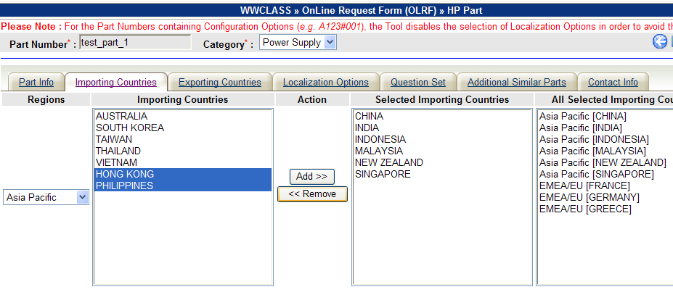
        - Sorting of Country List (Click Block Headings of “Importing Countries”, “Selected Importing Countries” and/or “All Selected Importing Countries” to sort them in ascending Order)
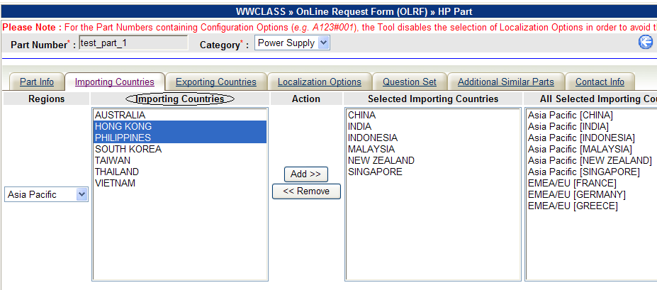

    - Tab : Exporting Countries (Optional)
      - This section allows user to select a list of Exporting Countries for Export Classification.
      - Multiple Exporting Countries can also be selected for Export Classification using same techniques as described under “Tab : Importing Countries” section above.
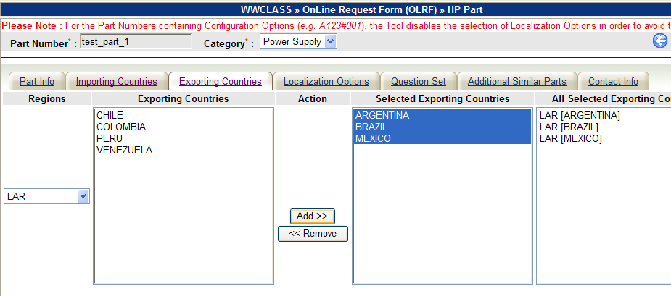

    - Tab : Localization Options (Optional)
      - The user can select any number of Localization Options here.
      - By applying same techniques as described under section “Tab : Importing Countries” multiple Localization Options can be selected.
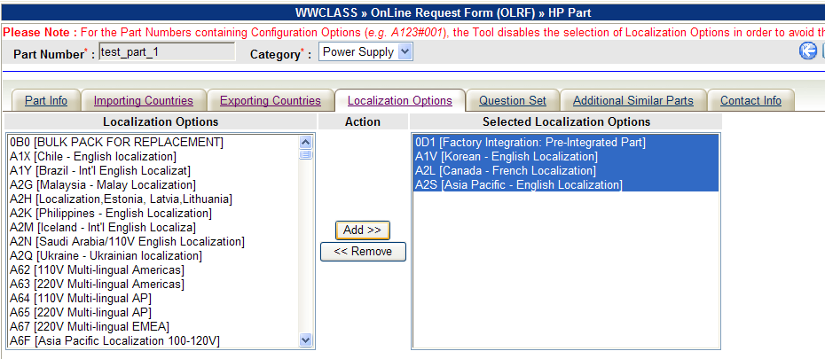
    - Tab : Question Set (Mandatory)
      - This Tab shows the Question Set pertaining to the Category selected at the beginning to be filled in.
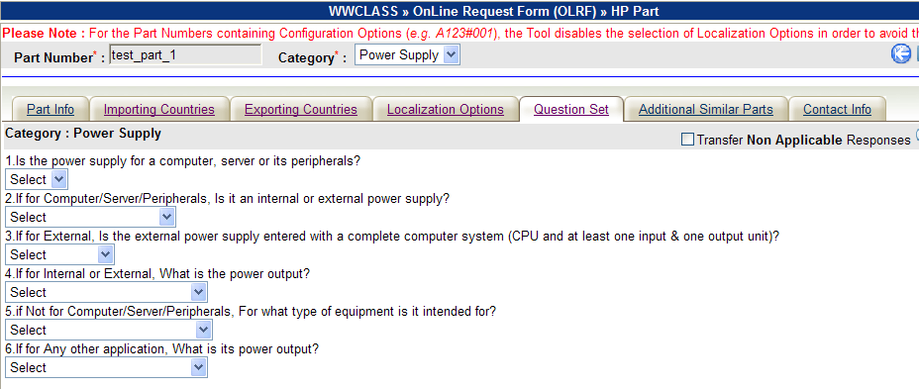
      - Selecting Response Options and Entering Response Texts (User must select a response Option or enter Response Text associated with each Question. Otherwise the form can not be submitted and the Tool will show the Error Messages pointing to the unselected Response fields associated with the Questions. If any question is not relevant to the context, then user can select or enter “Not Applicable” as response to that question.)
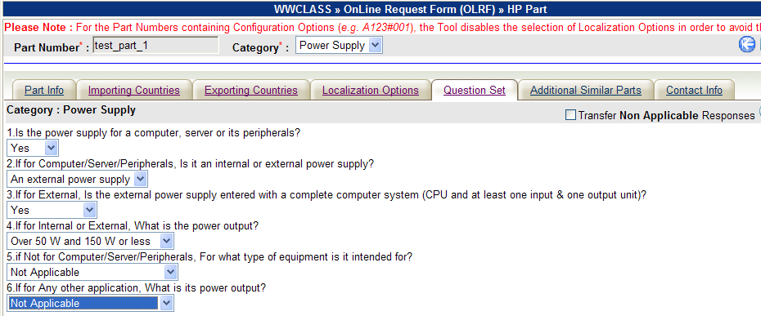
      - CheckBox – Transfer Non Applicable Responses : (By default the Tool ignores all “Non Applicable” responses. If the user wants to transfer all “Non Applicable” Responses, he/she can select the CheckBox.
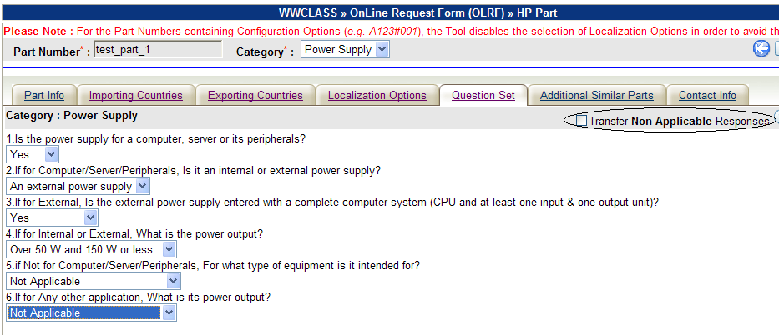

    - Tab : Additional Similar Parts (Optional)
      - Entering Classification Requests for Additional Similar Parts (In this section the tool allows users to enter additional Parts with descriptions which can have same Classification request Information (such as Product Line, Importing/Exporting Countries, Localization Options etc.) of the Base/Primary Part Number entered at the beginning. User can have option to enter /upload multiple such parts.)
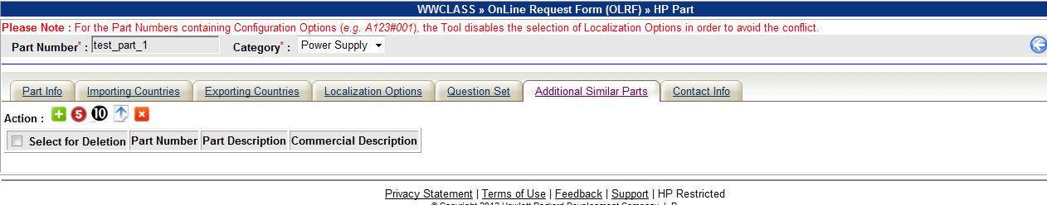
      - Control Buttons/Icons :
        -  → Click to add one Additional similar Part with Part Description and Commercial Description.
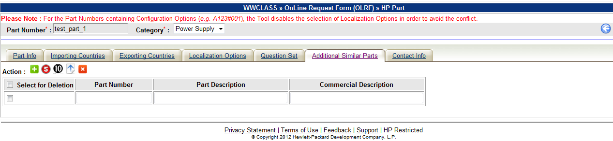
        - → Click to Add Five Additional similar Parts with Part Descriptions and Commercial Descriptions.
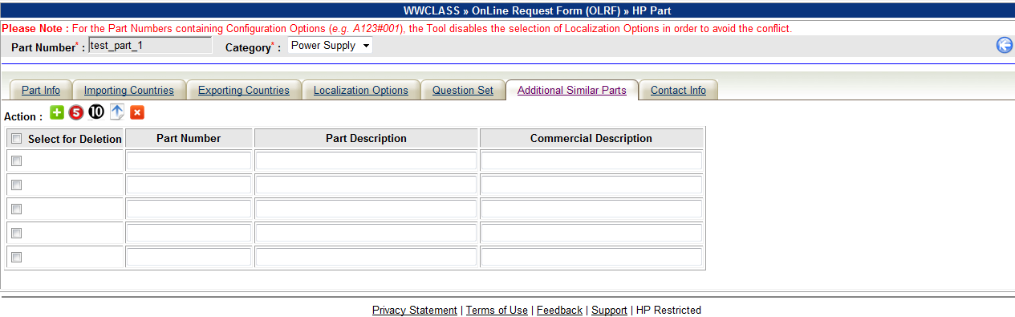
        -  → Click to Add Ten Additional similar Parts with Descriptions.
        - → Click to upload Parts from a text file. The text file should contain Part Numbers (Maximum Length : 20 Characters) and corresponding Part Names/Descriptions (Maximum Length : 40 Characters) separated by a TAB. A sample extract of a Tab delimited text file containing Part Numbers, Part Descriptions and Commercial Descriptions is shown below.
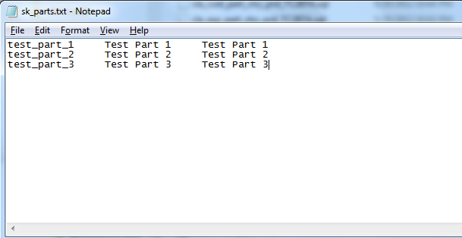
Users may initially create a Part File using a Spreadsheet by entering Part Number, Part Description and Commercial Description in separate Columns and then can save the Spreadsheet as a Tab Delimited Text File (File → Save As → Save As Type → Text (TAB Delimited)).
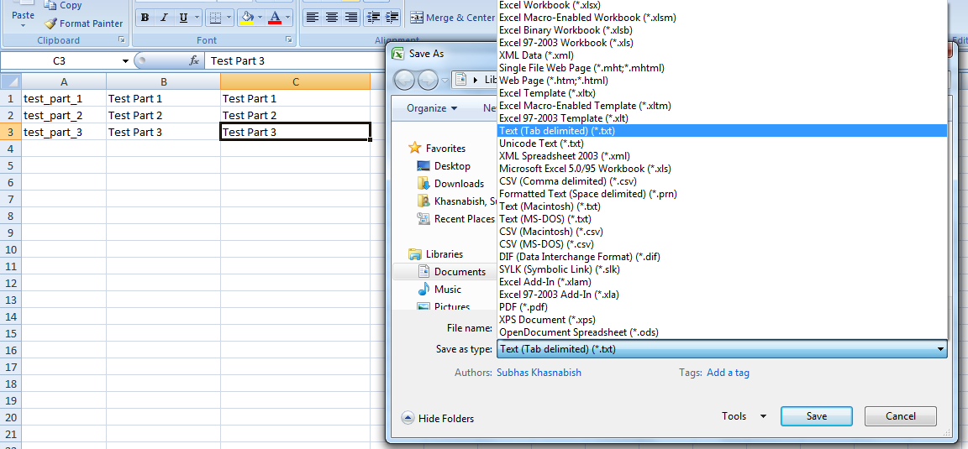

Note : In order to maintain the efficiency of performance, the Tool does not allow to upload more than 25 Parts using a Single File.

When Part Upload option is selected, the Tool opens up a block to select the Text file from the local Computer. It also provides necessary instructions to create a Tab Delimited Text file from Spreadsheet.
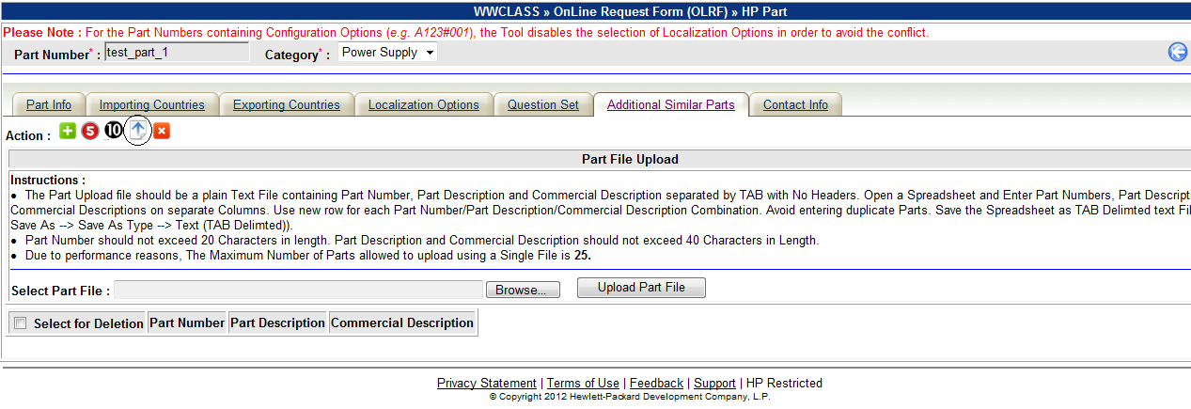
User may use “Browse” button to locate the Text file.
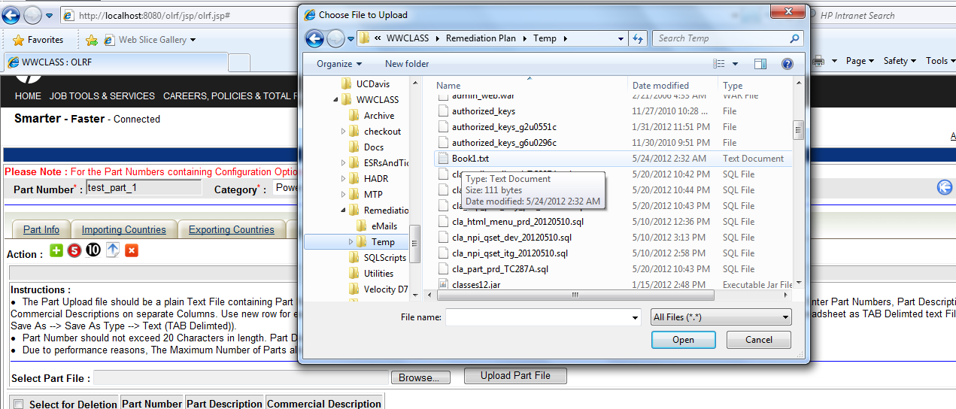
Once the Text File is selected, user can click “Upload Part File” Button to upload the Part Numbers, Part Descriptions and Commercial Descriptions onto the screen.
When “Upload Part File” Button is clicked, the tool performs following validation of the Data inside the Part Upload File as displays Error Message accordingly.
- Checks for Character Length of each Part Number.
- Checks for Character position of Configuration Option (if any) for each Part Number.
- Checks for Character Length of Part Description for each Part Number.
- Checks for Character Length of Commercial Description for each Part Number.
- Checks for Maximum Number of Parts allowed for Upload.
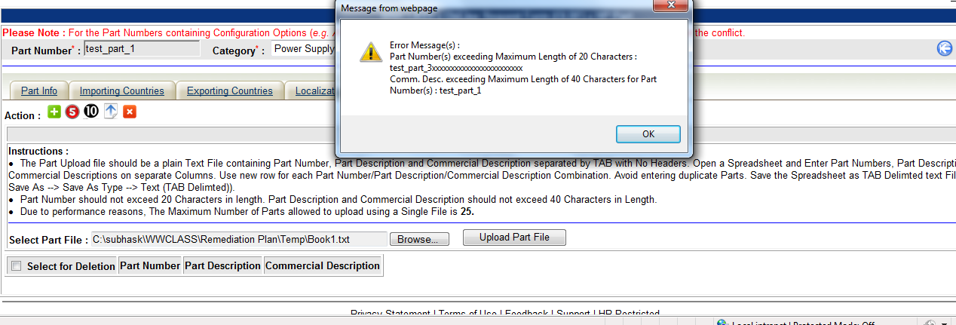

Once the validation phase is passed and no error is detected then the Tool uploads Part Numbers, Part Descriptions and Commercial Descriptions on the screen from the selected Text File.
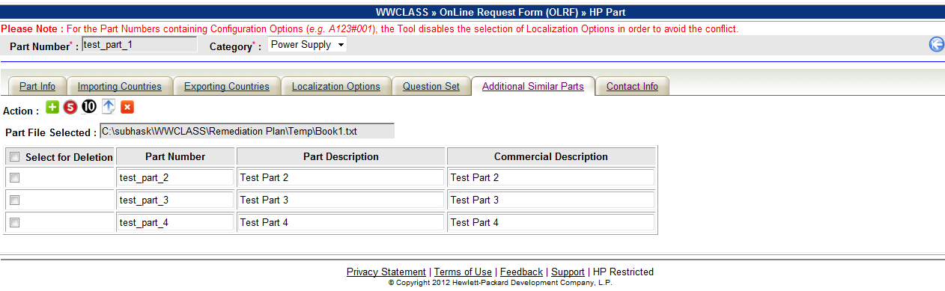
        - → Click to close the Part Upload Dialog Block.
        -  → When clicked, selected Additional similar Part blocks will be deleted. The Checkbox at the header (Select for Deletion) enables users to select or de-select all Part Numbers.
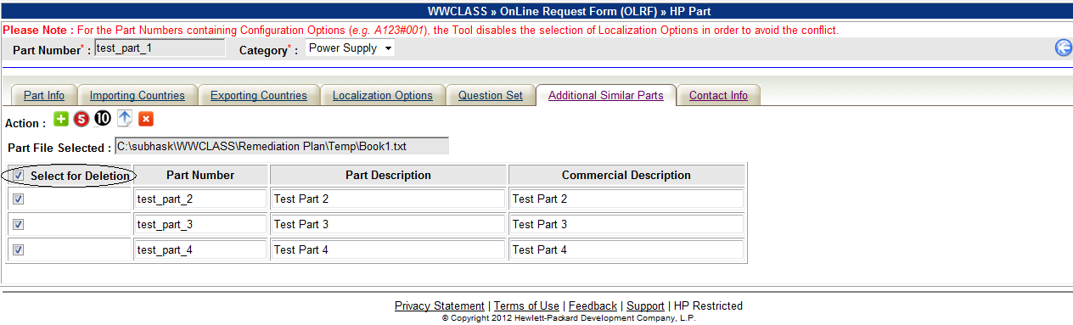
      - Once selected, user must have to enter Part Numbers and Descriptions for all Additional Similar Parts. If any Part Number and/or its Description field is left Blank, the tool will show Error message when  (Save) button/icon is clicked.
      - Deletion of unwanted Additional Part Rows : (The user can delete unwanted Parts by checking the Checkbox associated against each Additional Similar Part Row and then by clicking the deletion button/icon.)
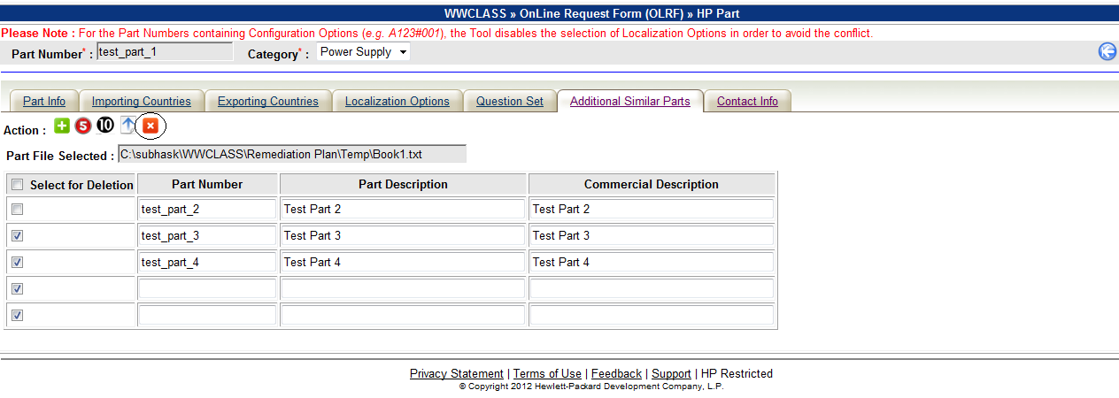
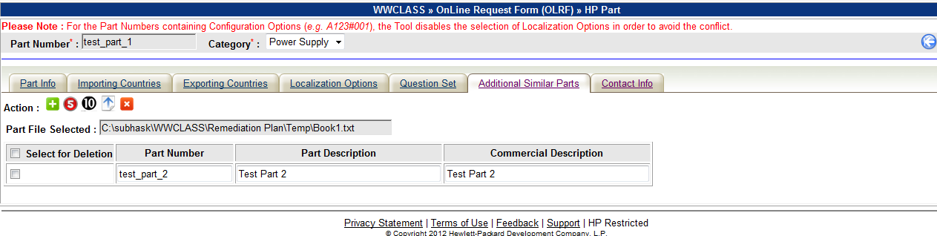
    - Tab : Contact Info (Mandatory)
      - This section allows users to enter contact related information (Product Information Website, Contact names and Email Ids) :
        - Following Fields are Mandatory to be entered :
          - Email of the Requestor (Accepts only HP Email address)
          - Email of the Technical Contact (Accepts only HP Email Address)
        - Following Fields are Optional :
          - Product Information Web Site
          - Name of the Requester
          - Phone # of the Requester
          - Name of Technical Contact
          - Phone # of the Technical Contact
          - Additional Email Addresses
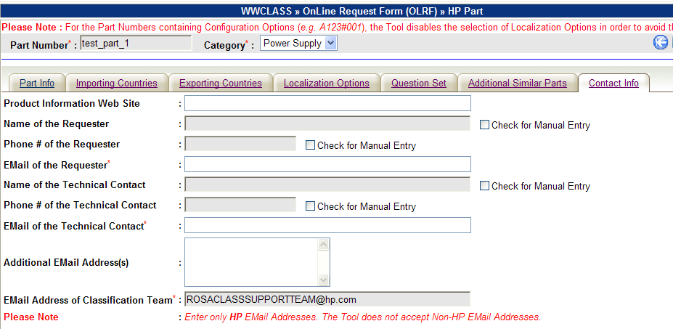

        - CheckBox – Check for Manual Entry :
          - If this Checkbox is unchecked then the tool fetches the Name and Phone Numbers from HP Enterprise Directory based on the valid HP Email Addresses entered when the form is submitted.
          - If this Checkbox is selected, the tool allows the user to make manual entry to the field. In that case, the tool does not fetch the information from HP Enterprise Directory. Once the checkbox is selected, user must have to enter the Name fields (Name of the Requester and Name of the Technical Contact) otherwise the tool will show “Field(s) Left Blank” Error and the form won’t be submitted.
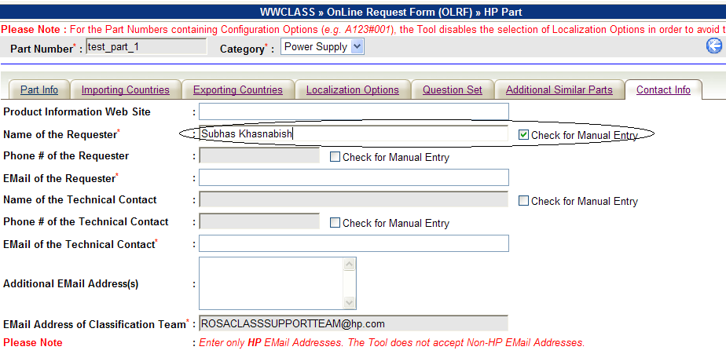

  - → Saving/Submitting the Form :
Following actions are performed by the tool when Save button/icon is clicked.
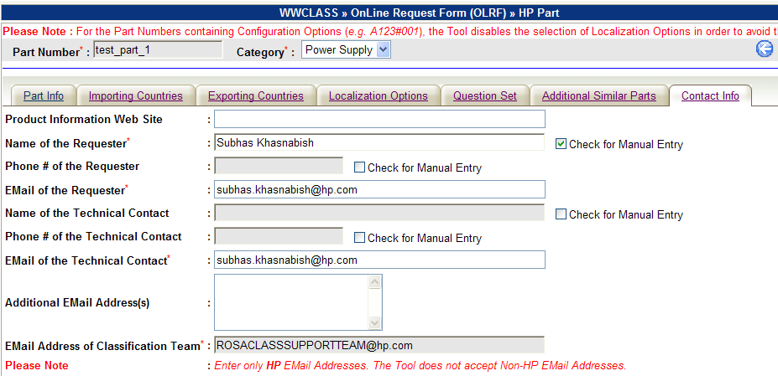
    - Input Data Validation for all Sections/Tabs
The Input Data Validation for the entire form including all Sections are done in two Stages/passes :
      - In First stage/pass, the tool checks for the Mandatory Fields which are left Blank and for the Non-HP Email addresses. If any mandatory field is left blank and/or any Email address field contains Non-HP Email Address, it displays the Error Message as shown below :
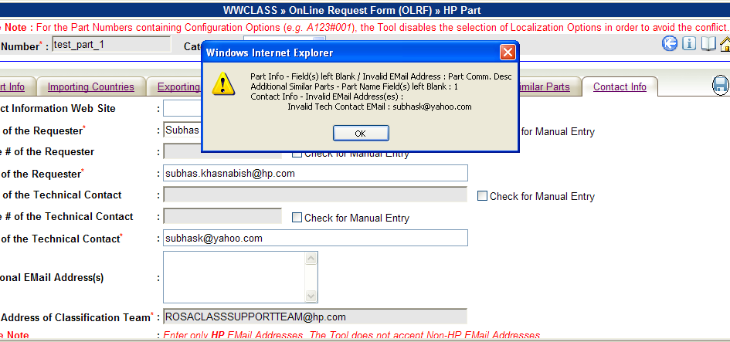
      - If no error found in First stage/pass, the tool then makes a real time call to HP Enterprise directory to check the Validity of all HP Email Addresses. If any of the Email Ids is not found in HP Enterprise Directory, then the tool displays the Error Message :
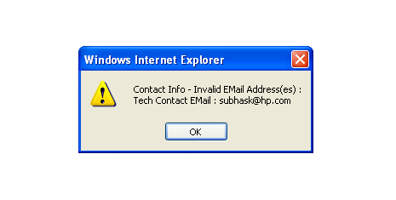
    - Post Submit Actions
If No Error is found during Input Data validation phase, the Tool then performs following actions :
      - Displaying Summary of Action Performed :
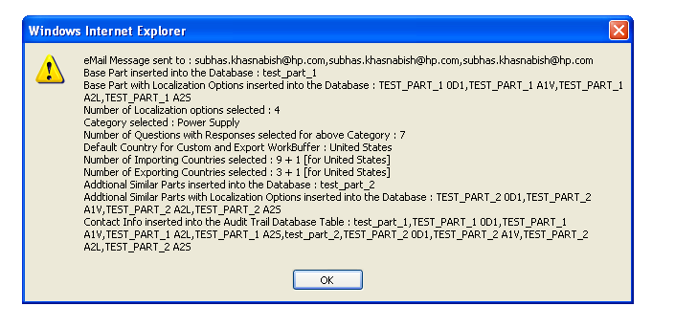
      - Sending Email notifications :
        - The Tool sends Email Notifications to the designated people with detail Classification Request Information.
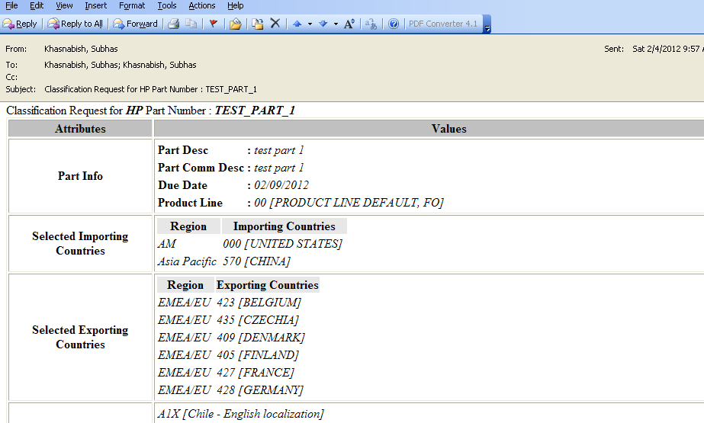

      - Updating Database
        - Creates New Part Record for Base Part Number and Additional Part Numbers (if any) in the Database (in CLA_PART Table). If the Part Number does not contain Configuration Option, then the tool generates New Part Numbers based on Localization Options.
        - Forms concatenated string of all Keywords (representing the questions) and corresponding Responses and then stores it in the Database (in CLA_CLASS_DESC table) against each Part Number.
        - Creates Classification request entries in Customs (CLA_CUST_WORKBUFFER Table) and Export (CLA_EXP_WORKBUFFER Table) Workbuffers based on the selection of Importing and Exporting Countries. The Country US is considered as a default Country for Custom and Export Classification. Even if, US is not selected by the user as Importing and/or Exporting Country, the tool creates entries for Custom and Export Classification request into the corresponding Workbuffer tables.
        - Updates Audit Trail Information for the Part (in CLA_AUDIT_TRAIL Table).
        - The newly added Part Information can be viewed using Part Lookup Function.
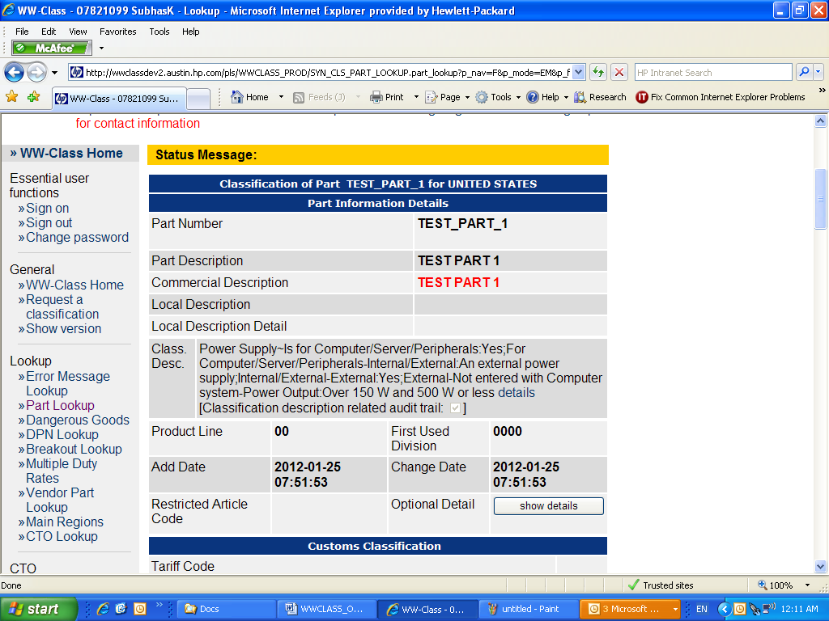

- Classification Request Form for NPNs (No Product Number) :

  - At the beginning following key fields are required to be entered :
    - Category (Must be selected from the Drop-Down List)
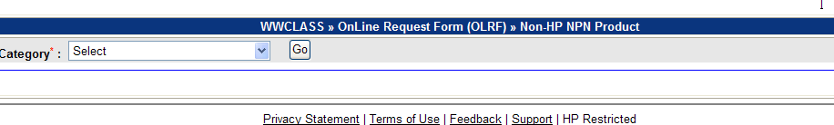
    - Click “Go” Button to submit the selected Category. On receipt of valid Category the Tool displays the Classification request form for NPNs in “Tab” Format.

  - The Control Buttons/icons are displayed :
    - → Start Over (When clicked, it refreshes the screen, wipes out data from previous operations.)
    - → Information/Instructions (When Clicked, displays popup window to show Information/Instructions)
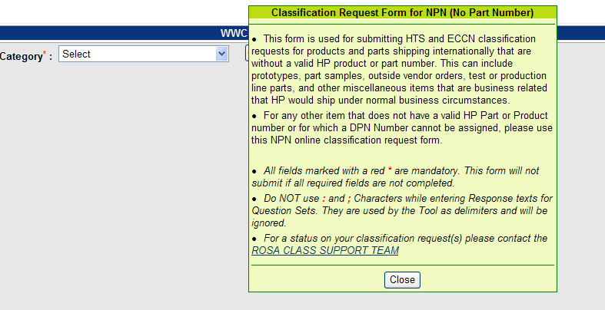
    - → User Guide for Operational Instructions
    - → Home (When Clicked, displays Home Page and Part Lookup Links.)

  - Input Validation :

    - If Category is not selected, the tool displays the Error Message as follows :
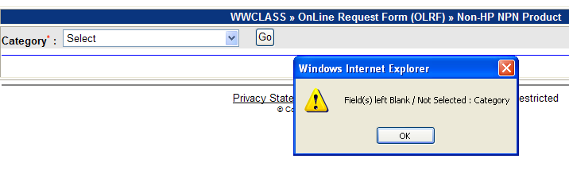

  - Next Screen : Detail Classification Request form :
    - On receipt of a Valid Category, the next screen displays the detail Classification Format in “Tab” format. Each “Tab” show relevant input section to be filled in. The Input fields marked with red Asterisks * denote mandatory fields to be filled in :
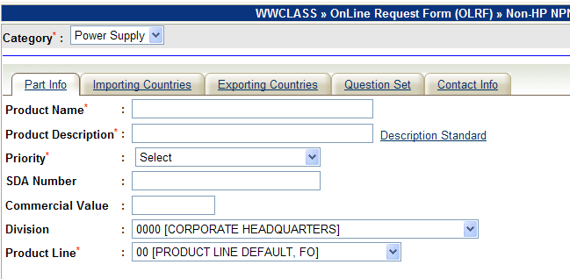
    - Tab : Part Info (Mandatory) :
      - Following Fields are mandatory to be filled in :
        - Product Name (Maximum Length : 40 Characters)
        - Product Description (Maximum Length : 40 Characters)
        - Priority (Select from Drop-down List)
        - Product Line (Select from Drop-down List).
      - Following Fields are Optional :
        - SDA Number (Maximum Length : 30 Characters)
        - Commercial Value (Maximum Length : 10 Characters)
        - Division (Drop-down List) – Default : 0000 [Corporate Headquarters]

    - Tab : Importing Countries (Optional)
      - Importing Countries “Tab” allows user to select Countries for Custom Classification based on the Regions.
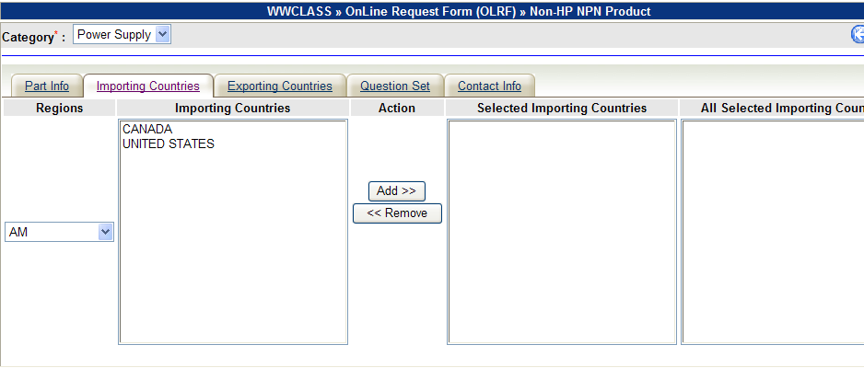
      - Following operations can be performed.
        - Selection of Region (From the left most Drop-down list Specific Region can be selected. When a Region is selected, the corresponding Countries belonging to that Region will appear inside the block of “Importing Countries” as shown below).
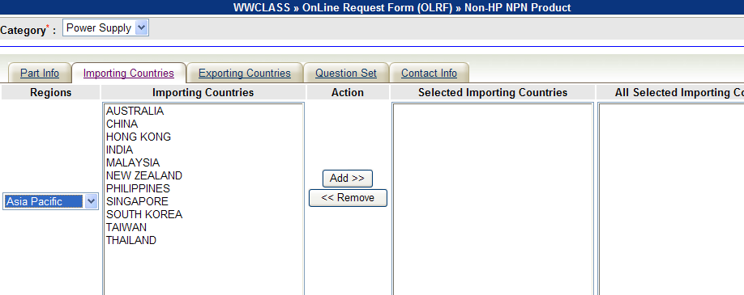
        - Selection of Multiple Importing Countries (Select/Highlight Country name to be selected. In order to select multiple Countries (not continuous), hold <ctrl> button on the keyboard and then click on next country as shown below. In order to select continuous group of countries, select the first Country and then hold <shift> button on the keyboard and click the last country to be selected as shown below)
          - Selection of multiple countries (not continuous) using <ctrl> and Mouse Click
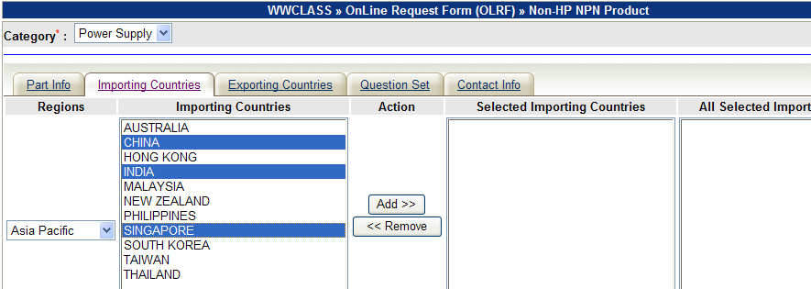
          - Selection of multiple countries (continuous) using <shift> and Mouse Click.
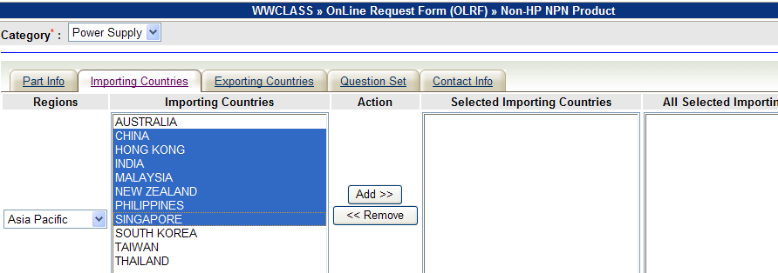
        - After highlighting the Countries (as shown above), click “Add” Button to add them into the “Selected Importing Countries” Block.
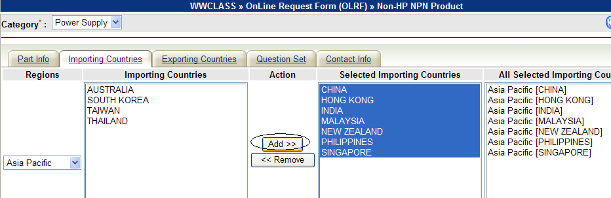

        - The Last Block titled “All Selected Importing Countries” shows the cumulative selection of Countries for all selected Regions.
        - The same process can be repeated to select Countries from other Regions. The last block will show the cumulating selection of Countries for all selected Region.
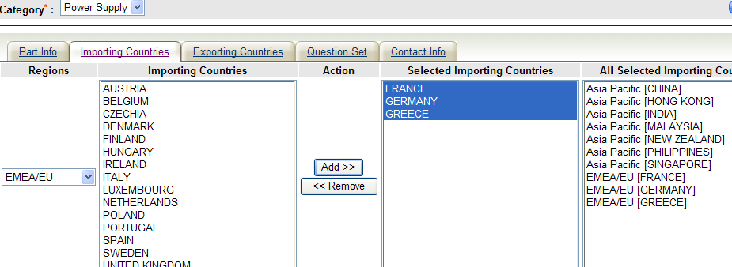
        - Deselecting Countries or Removing Countries from “Selected Importing Countries” Block : (Select/Highlight multiple countries from “Selected Importing Countries” Block using <ctrl>-Mouse Click or <shift>-Mouse Click techniques as described above and then click “Remove” button. The selected countries will be removed from “Selected Importing Countries” and “All Selected Importing Countries” blocks and will be appended to the “Importing Countries” block)
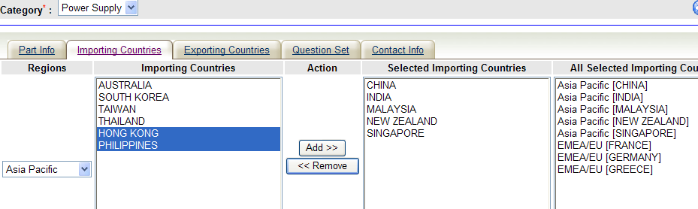
        - Sorting of Country List (Click Block Headings of “Importing Countries”, “Selected Importing Countries” and/or “All Selected Importing Countries” to sort them in ascending Order)
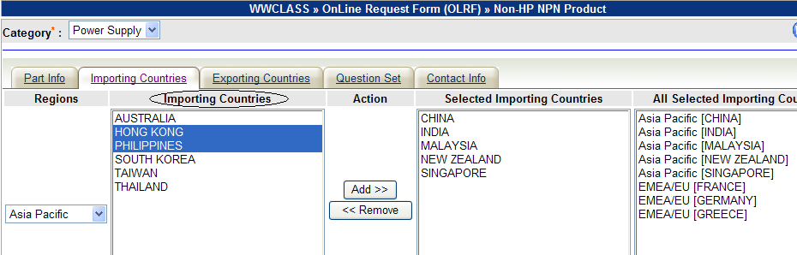

    - Tab : Exporting Countries (Optional)
      - This section allows user to select a list of Exporting Countries for Export Classification.
      - Multiple Exporting Countries can also be selected for Export Classification using same techniques as described under “Tab : Importing Countries” section above.
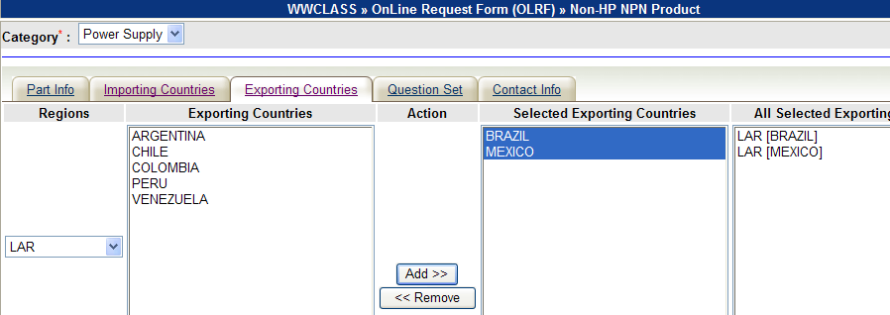

    - Tab : Question Set (Mandatory)
      - This Tab shows the Question Set pertaining to the Category selected at the beginning to be filled in.
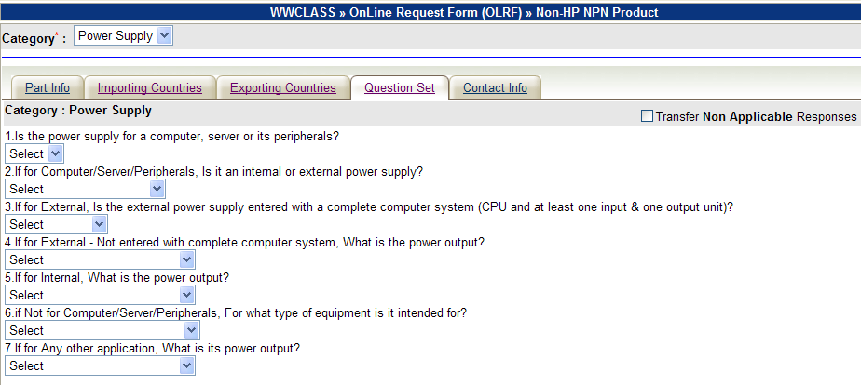
      - Selecting Response Options and Entering Response Texts (User must select a response Option or enter Response Text associated with each Question. Otherwise the form can not be submitted and the Tool will show the Error Messages pointing to the unselected Response fields associated with the Questions. If any question is not relevant to the context, then user can select or enter “Not Applicable” as response to that question.)
      - CheckBox – Transfer Non Applicable Responses : (By default the Tool ignores all “Non Applicable” responses. If the user wants to transfer all “Non Applicable” Responses, he/she can select the CheckBox.
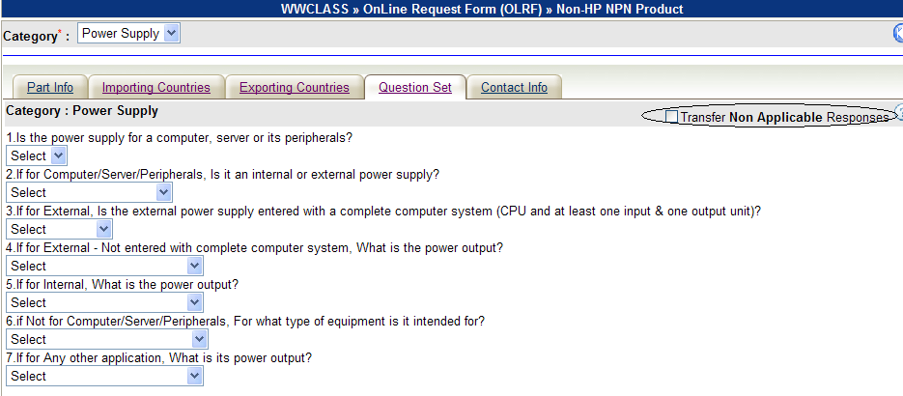
    - Tab : Contact Info (Mandatory)
      - This section allows users to enter contact related information (Product Information Website, Contact names and Email Ids) :
        - Following Fields are Mandatory to be entered :
          - Email of the Requester (Accepts only HP Email address)
          - Email of the Technical Contact (Accepts only HP Email Address)
        - Following Fields are Optional :
          - Product Information Web Site
          - Name of the Requester
          - Phone # of the Requester
          - Name of Technical Contact
          - Phone # of the Technical Contact
          - Additional Email Addresses
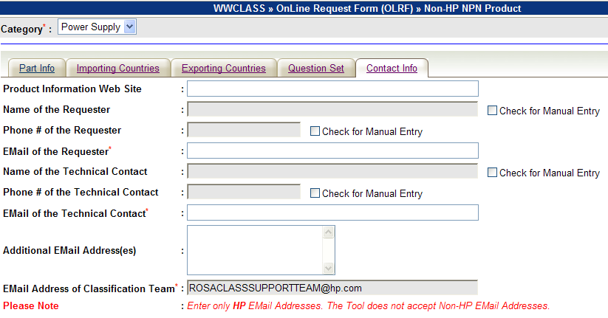
        - CheckBox – Check for Manual Entry :
          - If this Checkbox is unchecked then the tool fetches the Name and Phone Numbers from HP Enterprise Directory based on the valid HP Email Addresses entered when the form is submitted.
          - If this Checkbox is selected, the tool allows the user to make manual entry to the field. In that case, the tool does not fetch the information from HP Enterprise Directory. Once the checkbox is selected, user must have to enter the Name fields (Name of the Requester and Name of the Technical Contact) otherwise the tool will show “Field(s) Left Blank” Error and the form won’t be submitted.
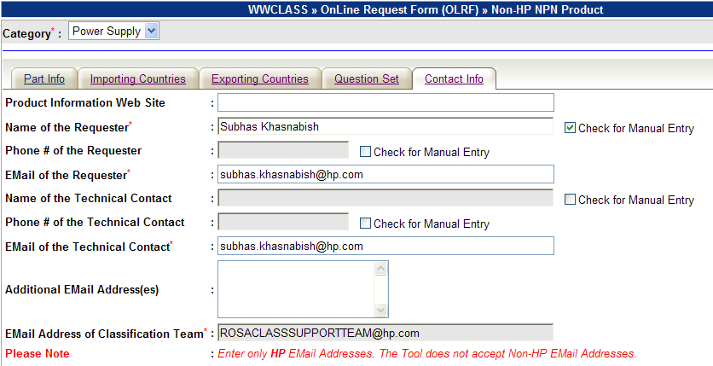

  - → Saving/Submitting the Form :
Following actions are performed by the tool when Save button/icon is clicked.
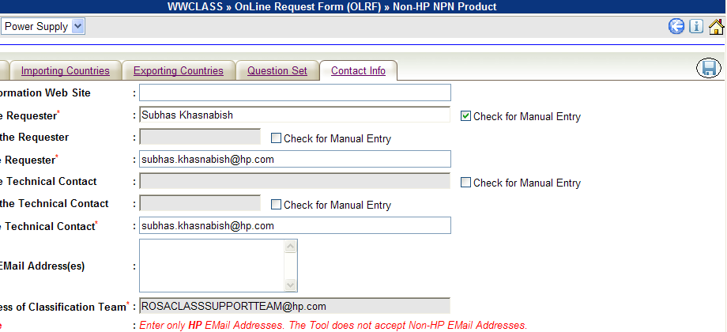
    - Input Data Validation for all Sections/Tabs
The Input Data Validation for the entire form including all Sections are done in two Stages/passes :
      - In First stage/pass, the tool checks for the Mandatory Fields which are left Blank and for the Non-HP Email addresses. If any mandatory field is left blank and/or any Email address field contains Non-HP Email Address, it displays the Error Message as shown below :
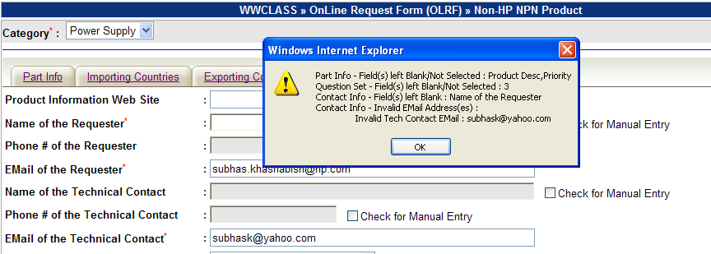
      - If no error found in First stage/pass, the tool then makes a real time call to HP Enterprise directory to check the Validity of all HP Email Addresses. If any of the Email Ids is not found in HP Enterprise Directory, then the tool displays the Error Message :
    - Post Submit Actions
If No Error is found during Input Data validation phase, the Tool then performs following actions :
      - Displaying Summary of Action Performed :
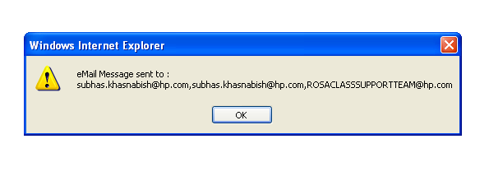
      - Sending Email notifications :
        - The Tool sends Email Notifications to the designated people with detail Classification Request Information. It also sends Email to the Class Team Support (ROSACLASSSUPPORTTEAM@hp.com) Mailbox.
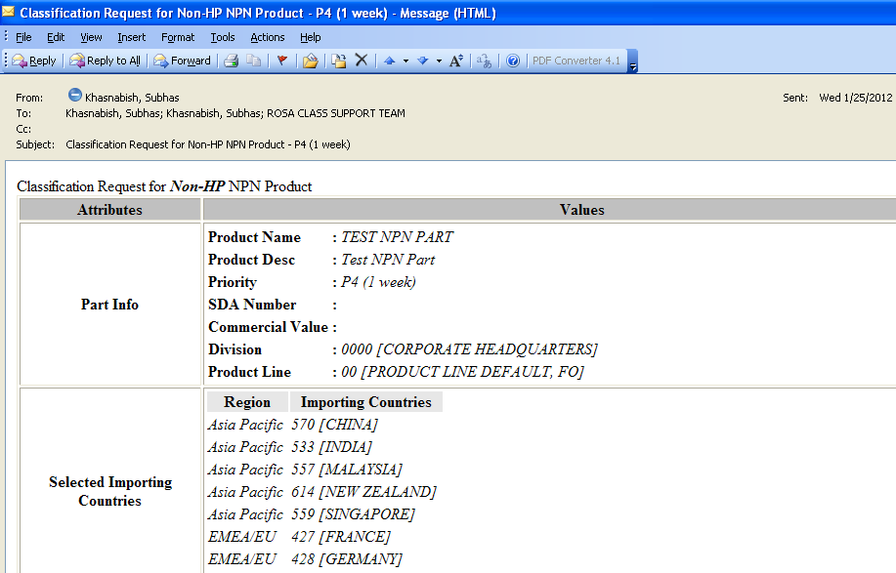

- Technical Details :
- Database Schema Name : CLSDBA
- Table Name for Question Sets : CLA_PART
- Table Structure :
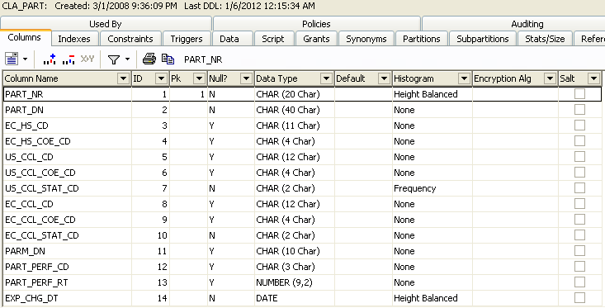
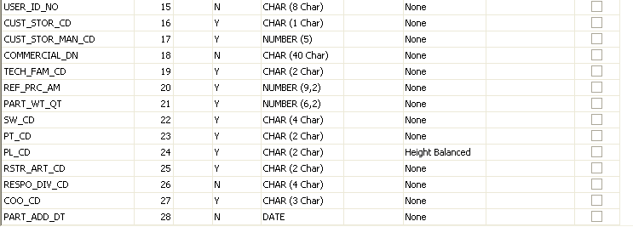
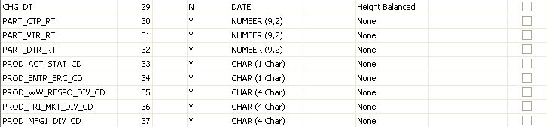

- Database Schema Name : CLSDBA
- Table Name for Question Sets : CLA_CUST_WORKBUFFER
- Table Structure :
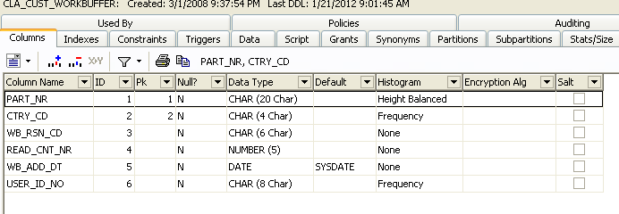

- Database Schema Name : CLSDBA
- Table Name for Question Sets : CLA_EXP_WORKBUFFER
- Table Structure :
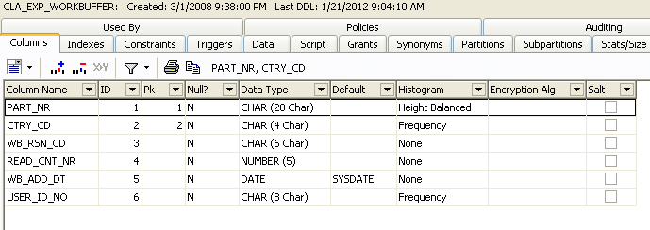

- Database Schema Name : CLSDBA
- Table Name for Question Sets : CLA_ClASS_DESC
- Table Structure :
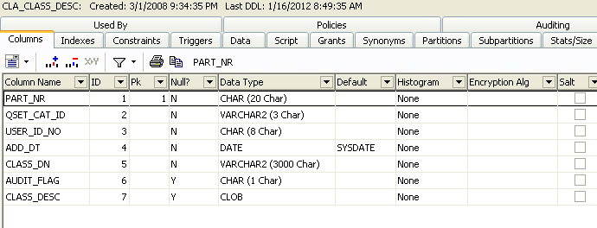

- Database Schema Name : CLSDBA
- Table Name for Question Sets : CLA_AUDIT_TRAIL
- Table Structure :


